**Bootstrap-Introduction**

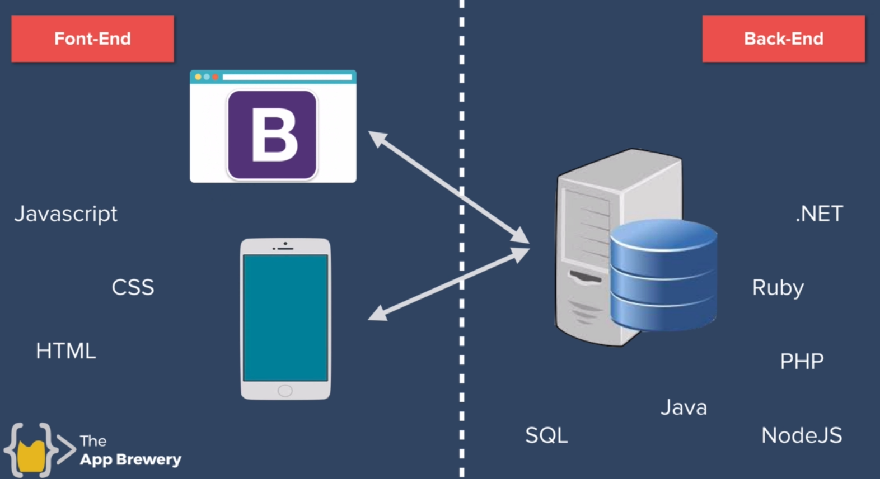

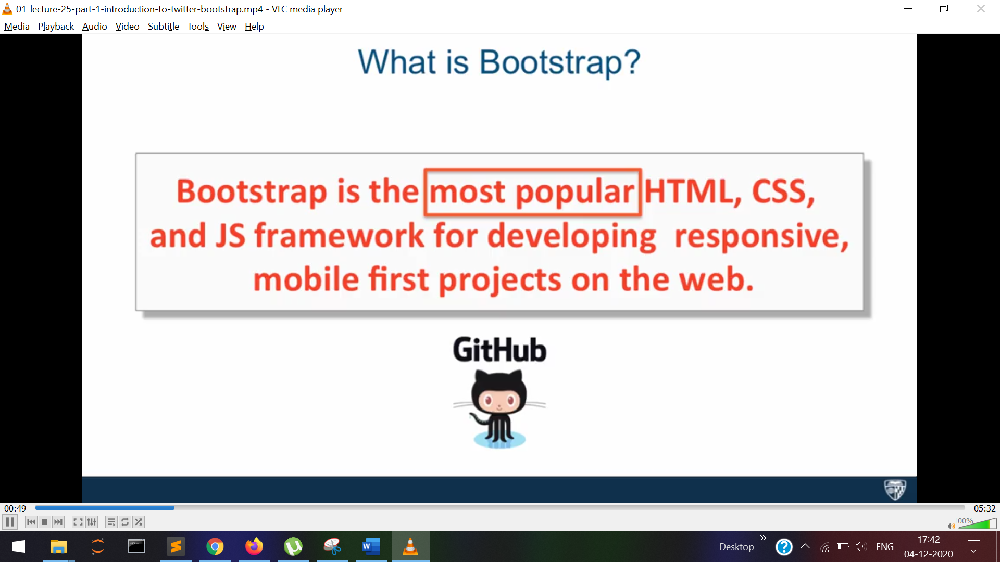

navbar-dark and navbar-light

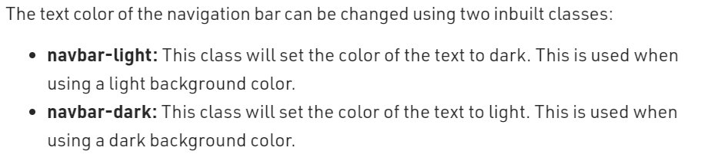

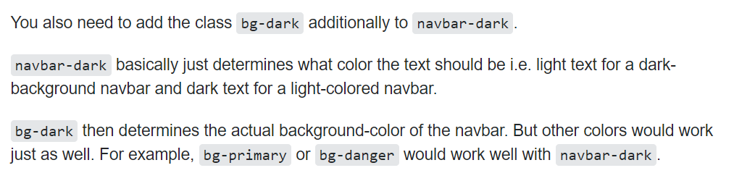

navbar-brand

